**NoteOfTheEverything**

Requirements Specification and Analysis

1.0

26.03.2021

Anzel Öztürk 215SE2303

Seray Şimşek 216CS2025

Prepared for

COMP/SOFT4902 Graduation Project



**Table of Contents**

1. Introduction 3

1.1. Purpose of the System 3

1.2. Scope of the System 3

1.3. Objectives and Success Criteria of the Project 3

1.4. Definitions, Acronyms, and Abbreviations 3

1.5. Overview 4

2. Current System 4

3. Proposed System 5

3.1. Overview 5

3.2. Functional Requirements 5

3.3. Nonfunctional Requirements 6

Usability 6

Reliability 6

Performance 6

Supportability 6

Implementation 6

Interface 6

Packaging 6

Legal 6

3.4. System Models 7

Scenarios 7

Use case model 16

Object model 36

Dynamic model 36

User interface—navigational paths and screen mock-ups 43

4. Glossary 57

5. References 57

**REQUIREMENTS ANALYSIS DOCUMENT**

1. **Introduction**

Nowadays, students are having a rough time trying to find notes for classes. There is always a price for notes online or there is a charge when they go to stationery. This situation affects the quality of the education in a bad way. In students' lives, reaching notes as fast as possible gives them more time. So we are creating a website named "NoteOfTheEverything" free and easily accessible which will make student’s life easier.

* 1. **Purpose of the System**

NoteOfTheEverything is a website developed for those who want to share lecture notes or find the course notes they are looking for. Anyone can register on the Website, share lecture notes, access other notes, give users points and ask questions to the Chatbot they want to ask.

* 1. **Scope of the System**

After the project completed, a note sharing site that everyone can easily use will be completed and the Admin page will be completed for control. The main idea of creating NoteOfTheEverything is to make sure that those looking for a lecture note can easily access the note they want and share the notes they want.

Unlike from all the website note sharing platforms, NoteOfTheEverything website model will be focused on the easiness for people and also Admin who controls the shared notes and possible problems on the website.

In the Admin panel, Admin can confirm sent notes before publishing.

* 1. **Objectives and Success Criteria of the Project**

The main goal of NoteOfTheEverything is to be the most used note sharing site in 1 year. NoteOfTheEverything should be easy to understand and accessible to everyone,

and the design of the website should always be user-friendly.

* 1. **Definitions, Acronyms, and Abbreviations**

RAD: Requirement Analysis Document

UI: User interface

IDE: Integrated Development Environment

* 1. **Overview**

Requirement Analysis Document includes five main heading. They are Introduction, Current System, Proposed System which include Functional Requirements, Nonfunctional Requirements and System Models, then finally Glossary and References.

First, in the Introduction part, we start with giving a short information about the system. Then we analyzed our purpose and explained what we expected from our project.

In the Current System part, we elaborated the feature and existing system of the current NoteOfTheEverything system which is based on a note sharing platform between the students. We explained the differences and disadvantages of our site from other sites.

In the Proposed System part, we find out features of our system. This part is divided into four subtitles. First, we mentioned the functional overview of the system in the Overview subtitle. Secondly, In the Functional Requirements part, we analyzed the functions and features of our system. The system functions on the system are defined based on our actors: Admin, Guest, Registered User. We connected our actors to the system and examined their relationship with our system. In the Nonfunctional Requirements part, we mentioned requirements that are nonfunctional, and this contains usability, reliability, performance, supportability, implementation, and interface, operational, packaging, and legal requirements. At the end of this section, there are System Models, in this part, we define and show use cases, scenarios, object models, UI and dynamic models for the system.

In the Glossary part, we described the terminology that we used in this document and determined the participating objects that are used in use cases.

In the References part, we showed the websites or documents we used while developing the project.

1. **Current System**

The current systems that are websites and they are used by the students. These websites are useful for students, but they are also harmful for the students financially.

Other websites cannot fully meet the needs of students. And they have some obstacles when the student uses the website. For example, money to access notes...

While design NoteOfTheEverything website, we tried to minimize these obstacles for students.

1. **Proposed System**

Generally, all other websites in this area are working in the discipline of ‘friendship’ or ‘money’, to eliminate these problems we decided to create a score point based program that secures any user that participates to the system can reach that much of other notes.

NoteOfTheEverything puts the user’s needs first place and has an artificial intelligence chatbot to answer the user’s questions. Chatbot’s name is “NoteBot”. Through to NoteBot users can find instant answers to their questions.

Notes are listed in order of score points, and this is a very efficient system for users.

* 1. **Overview**

NoteOfTheEverything project is a note sharing website which can be used by students.

This system has 3 types of users which are Admin, registered user, guest. The guest can only register to the system. Registered users can share their lecture notes, easily access the other people’s lecture notes that they are looking for and general actions done in the interface. For admins, they can confirm notes, delete notes, add general information on the website.

* 1. **Functional Requirements**

1. Guests must be able to register.
2. The registered user must be able to login.
3. The registered user must be able to share the lecture notes.
4. The registered user must be able to search.
5. The registered user must be able to filter.
6. The registered user must be able to change password.
7. The registered user must be able to change email.
8. The registered user must be able to change username.
9. The registered user must be able to add favorite lecture notes to the ‘My Favorites Notes’ part.
10. The registered user must be able to score the notes of the other user’s notes.
11. The registered user must be able to comment on the notes of the other user’s notes.
12. The registered user must be able to delete the notes she/he has uploaded.
13. The registered user must be able to delete the notes in the ‘My Favorites Notes’ part.
14. The registered user must be able to ask questions to the Chatbot.
15. The registered user must be able to logout.
16. The registered user must be able to click the forgot password option.
17. Admin must be able to login.
18. Admin must be able to confirm the sent notes and publish the confirmed notes.
    1. **Nonfunctional Requirements** 
       1. **Usability**

1.The website must be understandable for all users.

2.Admins should approve or delete notes on the website easily.

* + 1. **Reliability**

1. When the registered user searches for lecture notes, the system should be showing the correct lecture notes to the user in an acceptable time.
2. Admin responsible for validating notes for reliability.
   * 1. **Performance**

1. The website is accessed over the internet.

2. System is always available and access is guaranteed.

3. The system must return to the user within 3 seconds for each operation.

* + 1. **Supportability**

1. The NoteOfTheEverything note system should be managed by admin. Admin responsible for the approval of the notes for reliability.

2. When a problem occurs in the note section, it is immediately fixed by the admin.

* + 1. **Implementation**

1. The database will be created by using Django’s Database.

2. PyCharm will be used as a coding IDE.

3. Python will be used.

* + 1. **Interface**

*There is no such constraint in the project.

* + 1. **Packaging**

1. Our system is a website; you do not need to download anything. System is reachable through the server.

* + 1. **Legal**

1. The content of this project is protected by copyright law.

* 1. **System Models**
     1. **Scenarios**

**Scenario name**  HowToRegister?(Register)

**Participating Actors** Jack**:** Guest

**Flow of Events** 1. Jack is a college student and has difficulty finding notes while studying for the exam because he does not attend his classes regularly. He wants to register a site that he can find notes easily. He found out NoteOfTheEverything and opens site.

2.He sees that if he wants to see the notes he has to have an account.

3.Jack clicks the register button and fills the information about him like email, password, job ...

4.Jack sees a message about successfully saving his account.

**Scenario name**  WhatShouldIDoToFindANote?? (Login)

**Participating Actors** Rebecca**:** Registered User

**Flow of Events** 1. Rebecca wants to find a reliable and easy-to-understand note to study for the Spanish exam.

2. Rebecca enters the NoteOfTheEverything website and sees that she has to login for finding Spanish notes. She already has an account and she enters her mail and her password to the login site.

3. After that Rebecca uses Login button and successfully login into web page to find Spanish notes.

**Scenario name** IWantToShareMyNotes (Share)

**Participating Actors** Alex:Registered User

**Flow of Events** 1. Alex is a good university student, always takes notes in lectures and he wants to share his notes with other students.

2.He enters the “Share Notes” button on the HomePage and he uploads the notes in the share notes page.

3. He sees that site sending the note to the admin for approval.

**Scenario name** WhereIsTheChemistryNotes?(Search)

**Participating Actors** Toby:Registered User

**Flow of Events** 1. Toby is going to finish university and last exam is about Chemistry. He is looking on the internet but can’t find the specific notes for that subject.

2.He enters the search box and he types the subject.

3. He sees that site successfully show the chemistry notes he searches for.

**Scenario name** WhichOfThese?(Filter)

**Participating Actors** Miguel:Registered User

**Flow of Events** 1. Miguel is a civil engineer. When a customer wants to make a villa for his family, as Miguel starts to calculate how thick columns should be, he sees that he can’t remember how to calculate it.

2.So he enters the notes, he enters the filter box then he selects civil engineering notes, column calculation then he selects 0 to 2 years for better understanding.

3. He sees that site successfully showing the column calculations notes he searches for.

**Scenario name**  HowToChangePassword? (Change Password)

**Participating Actors** Kevin**:** Registered User

**Flow of Events** 1. Kevin thinks his password is simple and wants to set a harder password. He enters NoteOfTheEverything and login with his email and old password. Goes to my accounts section and selects the change password button.

2. In the change password page, he writes old passwords and new one that he wants to replace with.

3. He sees that site successfully replaces it with a new one.

**Scenario name**  HowToChangeEmail? (Change Email)

**Participating Actors** Kate:Registered User

**Flow of Events** 1. Kate no longer wants to use the old email address and creates a new email address for herself. She also wants to replace the old email address on the NoteOfTheEverything with the new one. She enters NoteOfTheEverything and login with her old email. Go to my accounts section and click the change email button.

2.She fills the sections about her old email and new one that she wants to replace with.

3.She wrote her new email addresses and verification code that site sends to email for verify.

4.She sees that site successfully replaces it with a new one.

**Scenario name**  HowToChangeUsername? (Change Username)

**Participating Actors** Beth**:** Registered User

**Flow of Events** 1. Since Beth got married two days ago, she no longer uses her old last name, she uses her husband's last name. She enters to NoteOfTheEverything and login with her email and password. Goes to my accounts section and selects the change username button.

2. In the change username page, she writes a new username that she wants to replace with.

3.She sees that site successfully replaces it with a new one.

**Scenario name**  HowCanIKeepNotes? (AddNotestoMyFavoriteNotes)

**Participating Actors** Edward :Registered User

**Flow of Events** 1. Edward uses this site always and he always forgot which note he used to use. Last week he used the “Programming Language” note and he wanted to use it this week, but he couldn’t find it again.

2.He found that note and selected that note to favorite.

3. He sees that site successfully saved that note to My Favorites section so that he can always look at that note whenever he wants.

**Scenario name**  ILikeThisNote (Score)

**Participating Actors** Jacob:Registered User

**Flow of Events** 1. Jacob couldn’t find the note he wanted to use in his Biology lesson. He searched some notes and some of them are useful but not efficient for what he is looking for.

2. He finally found what he was looking for and he is being so happy about it. He gives 5 of the notes score.

3. He sees that this note is placed at the top of the list because of its high score.

**Scenario name** IFoundAWrongFormulaInTheNote (Comment)

**Participating Actors** Sophie:Registered User

**Flow of Events** 1. Sophie was studying for her exam, looking at the notes.She realised that the formula inside the note was wrong.

2. She wanted to inform the other users and user who shared the note, then she wrote the correct formula as a comment below the note.

**Scenario name**  RemoveThisNote (DeleteNotes)

**Participating Actors** Bella :Registered User

**Flow of Events** 1. Bella uploaded a note to the system last year. Then, she didn’t like her own handwriting. So, she decided to delete that note.

2. When she deleted that note, she saw that this note was deleted in her notes.

**Scenario name**  RemoveThisFavoriteNote (DeleteFavoriteNotes)

**Participating Actors** Thomas:Registered User

**Flow of Events** 1. Thomas added a lecture note to his favorite notes last month for his exam. Now he wants to remove the note because his exam is over.

2. When he deleted that note, he saw that this note was deleted in his favorite notes part.

**Scenario name**  IHaveAQuestion (Chatbot)

**Participating Actors** Jasper:Registered User

**Flow of Events** 1. Jasper, searching notes about flex language and he does not know under which topic the subject he is looking for.

2. He writes that to Chatbot and gets an answer that “This subject is under the Principle of Programming Language notes.

**Scenario name**  HowToLogout? (Logout)

**Participating Actors** Bob**:** Registered User

**Flow of Events** 1. Bob enters the NoteOfTheEverything website and he studied his exam using notes inside the website.

2. He wants to continue tomorrow because he is tired of studying.

3. He clicks the logout button in the MyAccount part in the website.

**Scenario name**  Ohh!!IForgotMyPassword :( (Forgot Password)

**Participating Actors** Patrick**:** Registered User

**Flow of Events** 1. Patrick enters the NoteOfTheEverything website and he realizes that forgot his password.

2. He clicks the forgot password section in the login page.

3. He sees that website sent him a mail for a change password.

**Scenario name**  HowShoulICheckTheNotes? (Login)

**Participating Actors** Alice**:** Admin

**Flow of Events** 1. Alice’s job is looking for the notes that are uploaded by users and she gives this notes approval for the publication.

2. She wants to login to the site to check the notes. She fills the form on the login page and enters the system.

**Scenario name**  WhichNoteIsGoingToPublish? (Confirm)

**Participating Actors** Alice:Admin

**Flow of Events** 1. Alice is responsible for checking the notes. Because of this, note is proper for the system and understandable for users. So, she opens the note from the incoming note part.

2. She decides this note is suitable for the system and she gives approval to publish that note to the system.

* + 1. **Use case model**

**Use case name** Register

**Participating Actors** Initiated by Guest

**Flow of Events**

1. NoteOfTheEverything homepage shows register button and login page link.

2. Guest clicks the register button on the homepage to have an account in the site.

3. NoteOfTheEverything displays a blank form for registration and this form includes user’s informations such as full name, email address and password.

4. Guest fills this fields on the form with his/her informations and then clicks the “Register” button.

5. NoteOfTheEverything responds to the Guest by displaying a pop-up message which says “Your account is created successfully.” and then directs the User to the login page of the NoteOfTheEverything.

**Entry condition -** Guest clicks the register button of the NoteOfTheEverything .

**Exit condition** - Guest notices the “Your account is created successfully.” message of the system.

**Quality requirements** NoteOfTheEverything must deliver the new user to the database in 3 seconds.

**Use case name** Login

**Participating Actors** Initiated by Registered User

**Flow of Events** 1. Registered User fills the blank form with her/his email address and password in the Login page. After that, he/she clicks the “Login” button to open his/her account.

2. NoteOfTheEverything opens users’ account and shows the user’s.

username in the upper right corner of the homepage.

**Entry condition -**Registered User enters the login page of the NoteOfTheEverything.

**Exit condition** - Registered User enters his/her account in the site and located on the

his/her homepage.

**Quality requirements -** NoteOfTheEverything must not show a given password on screen.

**Use case name** ShareLectureNotes

**Participating Actors** Initiated by Registered User

**Flow of Events** 1. Registered User adds their lecture notes to the “MyNotes” section and then clicks the “Share” button.

2.NoteOfTheEverything responds to the Registered User by displaying a message which says “Your note has been sent to admin approval for publication.”.

**Entry condition -** Registered User is logged in to NoteOfTheEverything with his/her username and password.

**Exit condition** - Registered User notices a message of the NoteOfTheEverything as a response which says “Approval is pending”.

**Quality requirements -**NoteOfTheEverything should keep the user notes safe.

**Use case name** SearchSomething

**Participating Actors** Initiated by Registered User

**Flow of Events** 1. Registered User writes the note they want to find in the search box and then clicks the “Search” button.

2.NoteOfTheEverything responds to the Registered User by showing appropriate notes to the user’s search.

**Entry condition -** Registered User is logged in to NoteOfTheEverything with his/her username and password.

**Exit condition** - Registered User notices a message of the NoteOfTheEverything as a response which says “Suitable notes have been found”.

**Quality requirements -**NoteOfTheEverything must deliver the search results to the system in 2 seconds.

**Use case name** Filter

**Participating Actors** Initiated by Registered User

**Flow of Events** 1. Registered User choose features of the notes they want to find in the filter boxes and then click the “Find” button.

2.NoteOfTheEverything responds to the Registered User by showing appropriate notes to the user’s search.

**Entry condition -** Registered User is logged in to NoteOfTheEverything with his/her username and password.

**Exit condition** - Registered User notices a message of the NoteOfTheEverything as a response which says “Appropriate notes found for filtering”.

**Quality requirements -**NoteOfTheEverything must deliver the search results to the system in 2 seconds.

**Use case name** ChangePassword

**Participating Actors** Initiated by Registered User

**Flow of Events**

1.Registered user enters the NoteOfTheEverything website and then clicks the Change Password button under the My Account part.

2.NoteOftheEverything shows a blank form in response to the user.

3.The user enters the old password once and the new password twice in the blank form.

4.NoteOftheEverything shows the message "Password change process completed successfully" to the user.

**Entry condition -** Registered User is logged in to the NoteOfTheEverything with his/her username and password.

**Exit condition -** Registered User notices a message of the NoteOfTheEverything as a response which says “Password change process completed successfully”.

**Quality requirements -** NoteOfTheEverything must encrypt passwords for security.

**Use case name** ChangeE-Mail

**Participating Actors** Initiated by Registered User

**Flow of Events** 1. Registered user enters the NoteOfTheEverything website and then clicks the Change Email button under the My Account part.

2. NoteOftheEverything shows a blank form in response to the user.

3. The user enters the new email address and verification code in her/his email address in the blank form.

4. NoteOftheEverything shows the message "Email change process completed successfully" to the user.

**Entry condition -** Registered User is logged in to NoteOfTheEverything with his/her username and password.

**Exit condition -** Registered User notices a message of the NoteOfTheEverything as a response which says “Email change process completed successfully”.

**Quality requirements** User should understand the interface of the page.

**Use case name** ChangeUserName

**Participating Actors** Initiated by Registered User

**Flow of Events** 1. Registered user enters the NoteOfTheEverything website and

then clicks the Change Username button under the My Account part.

2. NoteOftheEverything shows a blank form in response to the user.

3. The user enters the new username once in the blank form.

4. NoteOftheEverything shows the message "Username change process completed successfully" to the user.

**Entry condition -** Registered User is logged in to NoteOfTheEverything with his/her username and password.

**Exit condition -** Registered User notices a message of the NoteOfTheEverything as a response which says “Username change process completed successfully”.

**Quality requirements -**User should easily understand the interface of the page.

**Use case name** FavoriteLectures

**Participating Actors** Initiated by Registered User

**Flow of Events** 1. . Registered user enters the NoteOfTheEverything website andthen clicks the “My Favorite Lectures” button.

2. NoteOfTheEverything responds to the Registered User by

displaying all Notes that are his/her favorite ones.

3. Registered User, select one of them to see inside of the note.

4. NoteOfTheEverything responds to the Registered User by opens the selected note.

**Entry condition -** Registered User is logged in to NoteOfTheEverything with his/her username and password.

**Exit condition** - Registered User notices a message of the NoteOfTheEverything as a response which says “Selected note is opening.”.

**Quality requirements** User should easily understand the interface of the page.

**Use case name** GiveScore

**Participating Actors** Initiated by Registered User

**Flow of Events** 1. Registered User enters the selected note’s page.

2. NoteOfTheEverything responds to the Registered User by

displaying notes that he\she selected.

3. Registered User gives a score out of 5 to the note that he/she read.

**Entry condition -** Registered User is logged in to NoteOfTheEverything with his/her username and password.

**Exit condition** - Registered User notices a message of the NoteOfTheEverything as a response which says “Thanks for the score.”.

**Quality requirements** User should easily understand the interface of the page.

**Use case name** ToComment

**Participating Actors** Initiated by Registered User

**Flow of Events** 1. Registered User enters the note’s page that he/she wants.

2. NoteOfTheEverything responds to the Registered User by

displaying notes that he\she selected.

3. Registered User comments the note that he/she read.

**Entry condition -** Registered User is logged in to NoteOfTheEverything with his/her username and password.

**Exit condition** - Registered User notices a message of the NoteOfTheEverything as a response which says “Thanks for the comment.”.

**Quality requirements -** User should easily understand the interface of the page.

**Use case name** DeleteNote

**Participating Actors** Initiated by Registered User

**Flow of Events** 1. Registered User opens the “MyNotes” section and chooses the note that he/she wants to delete and clicks the “Delete” button.

2.NoteOfTheEverything responds to the Registered User by displaying a message which says “Do you want to delete Note1?”.

3.Registered User selects yes button.

4. NoteOfTheEverything responds to the Registered User by displaying a message which says “Deleted Successfully”.

**Entry condition -** Registered User is logged in to NoteOfTheEverything with his/her username and password.

**Exit condition** - Registered User notices a message of the NoteOfTheEverything as a response which says “Deleted Successfully”.

**Quality requirements -**NoteOfTheEverything must delete the note in the system in a short time.

**Use case name** DeleteMyFavoriteNote

**Participating Actors** Initiated by Registered User

**Flow of Events** 1. Registered User opens the “MyFavoriteNotes” section and chooses the note that he/she wants to delete and clicks the “Delete” button.

2.NoteOfTheEverything responds to the Registered User by displaying a message which says “Do you want to delete note?”.

3.Registered User selects yes button.

4. NoteOfTheEverything responds to the Registered User by displaying a message which says “Deleted Successfully”.

**Entry condition -** Registered User is logged in to NoteOfTheEverything with his/her username and password.

**Exit condition** - Registered User notices a message of the NoteOfTheEverything as a response which says “Deleted Successfully”.

**Quality requirements -**NoteOfTheEverything must delete the note in the system in a short time.

**Use case name** AskToChatbot

**Participating Actors** Initiated by Registered User

**Flow of Events** 1. Registered User opens the chatbot.

2.NoteOfTheEverything responds by opening the chatbot and displays “Hello RegisteredUser!”.

3.Registered User writes questions about the site.

4.Chatbot answers his\her questions.

**Entry condition -** Registered User is logged in to NoteOfTheEverything with his/her username and password.

**Exit condition** - Registered User clicks the close button of the chatbot.

**Quality requirements -**NoteOfTheEverything must deliver the answers to the system in a short time.

**Use case name** Logout

**Participating Actors** Initiated by Registered User

**Flow of Events** 1. Registered User enters the “Logout” section of the MyAccount part in the NoteOfTheEverything.

2. NoteOfTheEverything responds to the Registered User by redirecting a “login” page.

**Entry condition -** Registered User is logged in to the NoteOfTheEverything with his/her username and password.

**Exit condition -** Registered User sees the NoteOfTheEverything as a response which redirects to the “Login” page.

**Quality requirements -**Registered user logged out in 2 seconds.

**Use case name** ForgotPassword

**Participating Actors** Initiated by Registered User

**Flow of Events** 1. Registered user enters the login page of the NoteOfTheEverything website and then clicks the “Forgot Password” button under the login form part.

2. NoteOfTheEverything responds to the Registered User by

sending an email.

3. Registered User, clicks the link inside of the email and enters a new password 2 times and then clicks the “Save” button.

4. NoteOfTheEverything responds to the Registered User by displaying a message which says “Your new password saved successfully”.

**Entry condition -** Registered User is logged in to the NoteOfTheEverything with his/her username and password.

**Exit condition -** Registered User notices a message of the NoteOfTheEverything as a response which says “Your new password saved successfully”.

**Quality requirements** NoteOfTheEverything must encrypt passwords for security.

**Use case name** AdminLogin

**Participating Actors** Initiated by Admin

**Flow of Events** 1. Admin fills the blank spaces with her/his email address and password. After that, he/she clicks the “Login” button.

2. NoteOfTheEverything responds to the user by showing the admin’s username in the upper right corner of the homepage.

**Entry condition -**Admin enters the login page of the NoteOfTheEverything.

**Exit condition** - Admin receives the home page of the NoteOfTheEverything and notices his/her name on the upper right corner of the page.

**Quality requirements -** NoteOfTheEverything must not show a given password on screen.

**Use case name** ConfirmNotes

**Participating Actors** Initiated by Admin

**Flow of Events** 1. Admin opens the incoming notes.

2.NoteOfTheEverything responds by opening the notes.

3.Admin checks notes and gives approval to publish on the site.

4. NoteOfTheEverything responds to the Admin by displaying a message which says “Publishing successfully…”.

**Entry condition -** Admin is logged in to the NoteOfTheEverything with his/her username and password.

**Exit condition** - Admin clicks on the close button.

**Quality requirements -**NoteOfTheEverything must deliver the notes to the system in a short time.

* **Use Case Model**

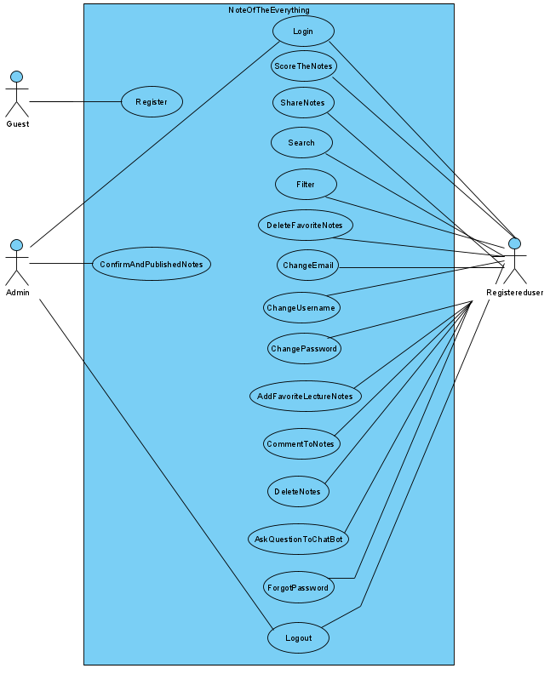

* + 1. **Object model**

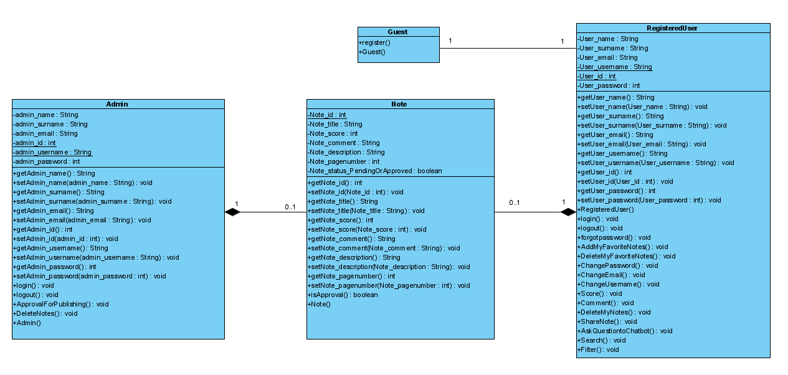

* + 1. **Dynamic model**
* ***Login***

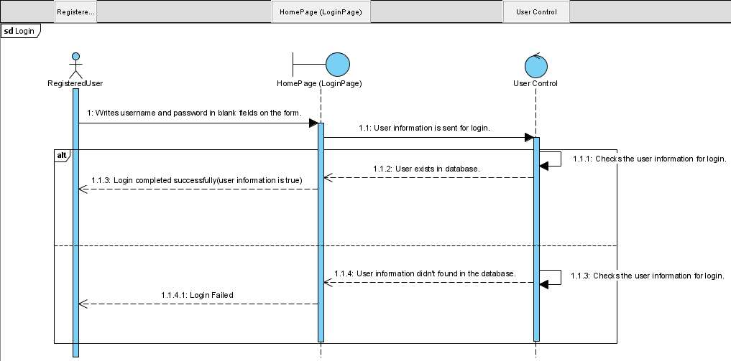

* ***Register***

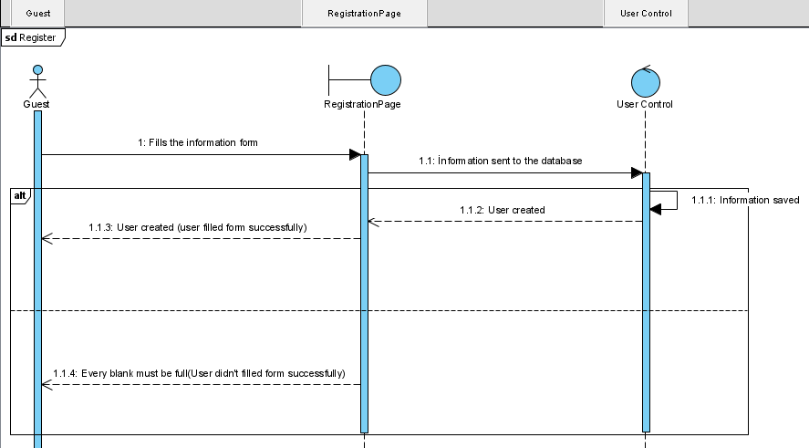

* ***Logout***

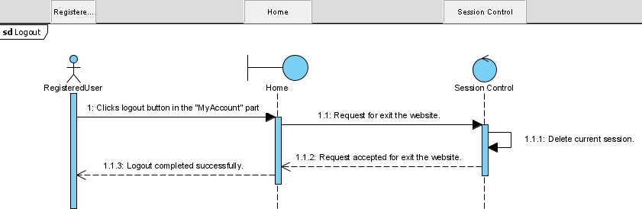

* ***Score***

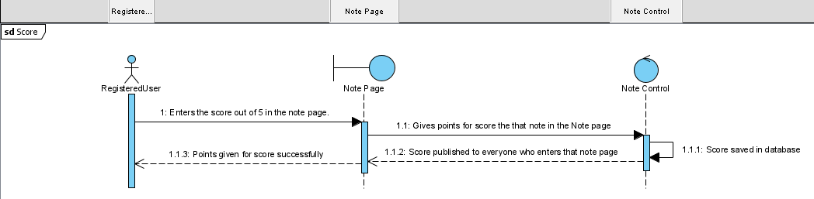

* ***Search***

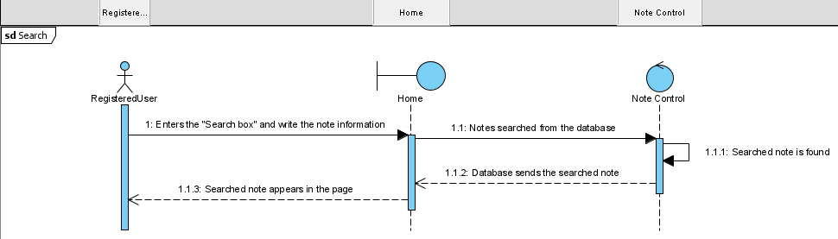

* ***Share Note***

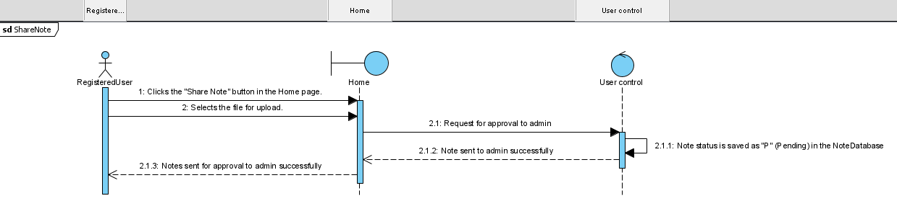

* ***Forgot Password***

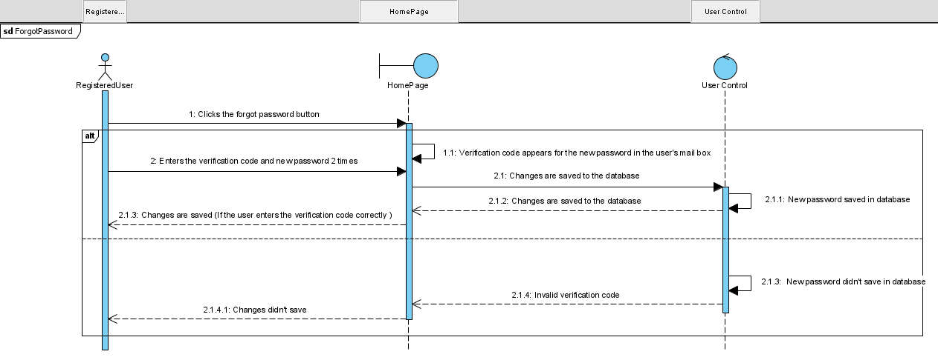

* ***Filter***

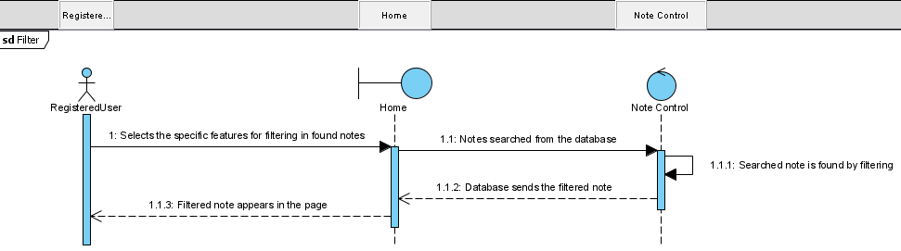

* ***Delete Notes in the My Favorite Notes part***

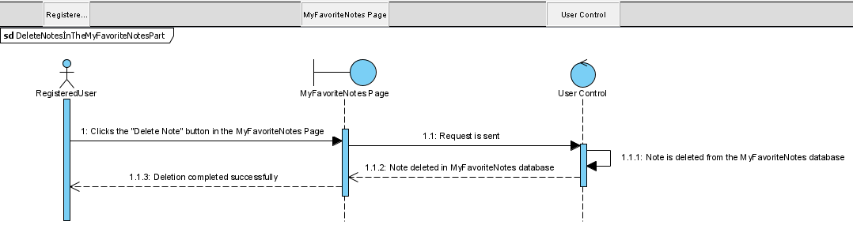

* ***Delete Notes in the My Notes part***

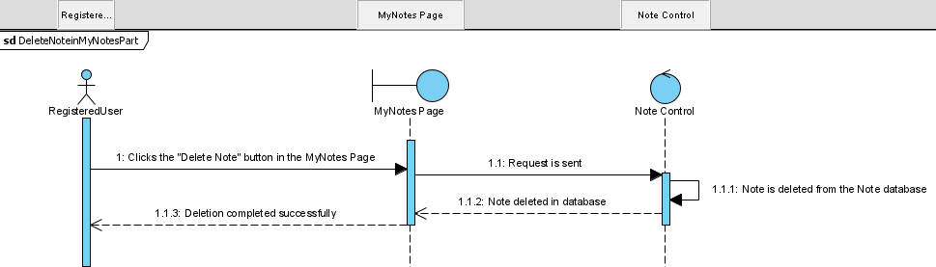

* ***Comment***

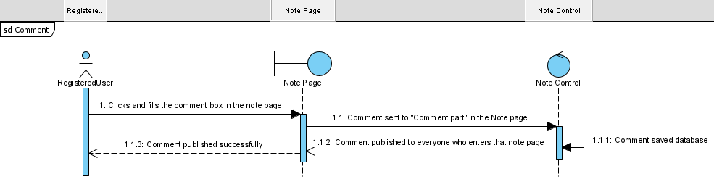

* ***Chatbot (NoteBot)***

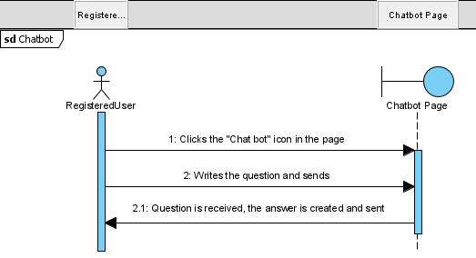

* ***Change Username***

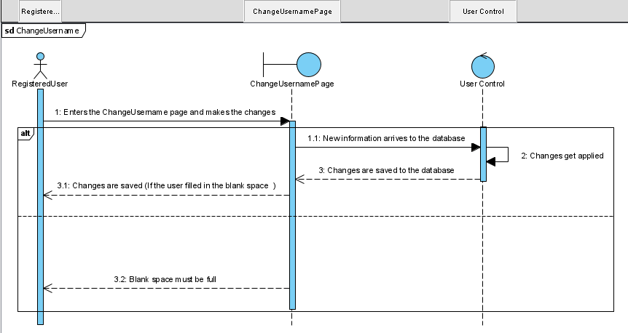

* ***Change Password***

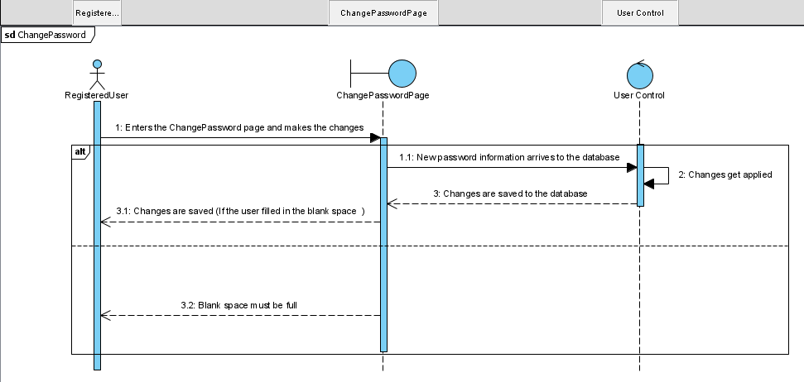

* ***Change Email***

***Chan***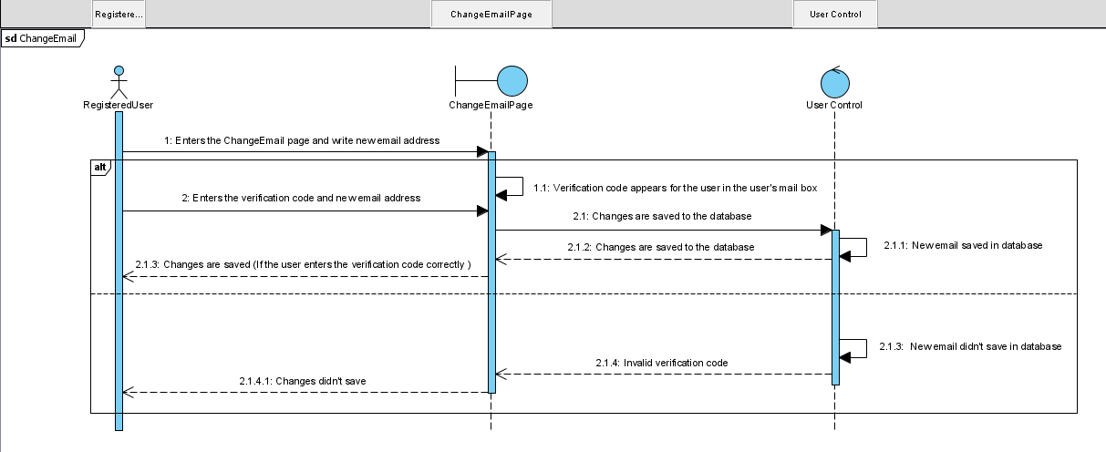

* ***Add notes to My Favorite Notes part***

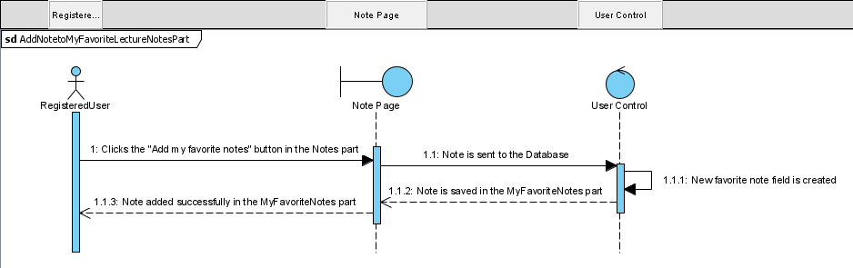

* ***Admin Login***

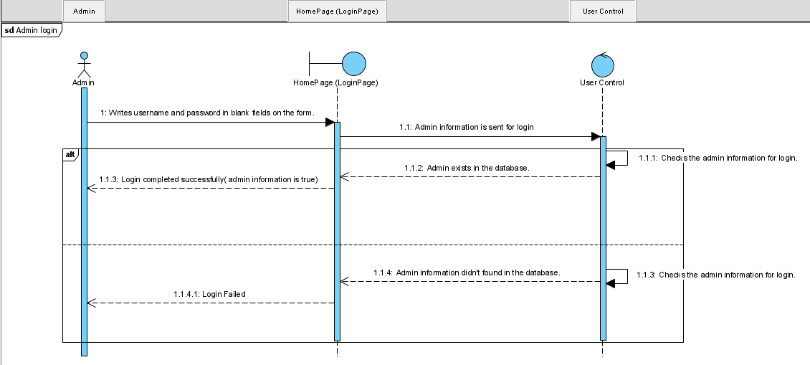

* ***Admin Confirm***

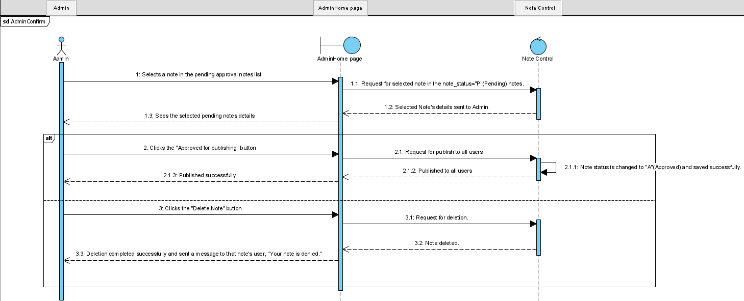

* + 1. **User interface—navigational paths and screen mock-ups**

**-Guest HomePage**

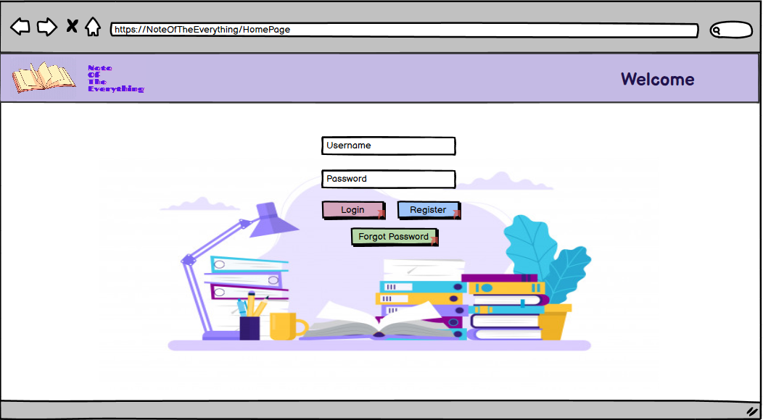

**-Registration Page**

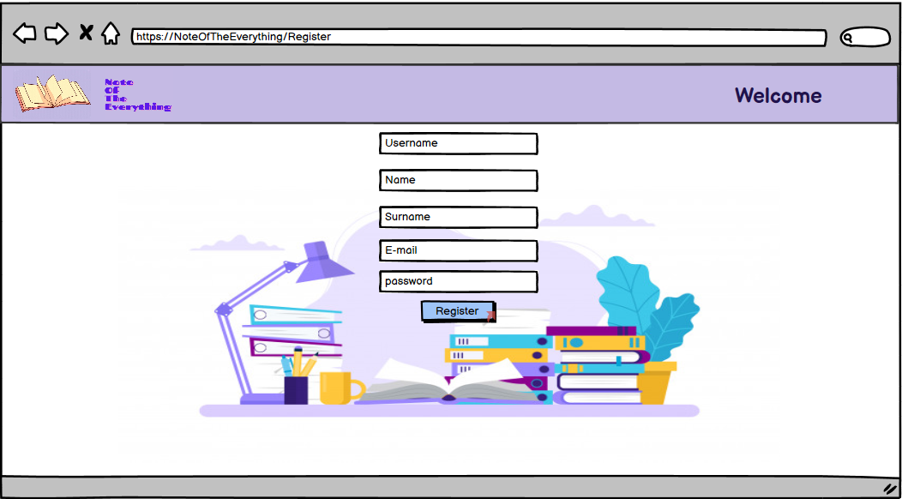

**-Forgot Password**

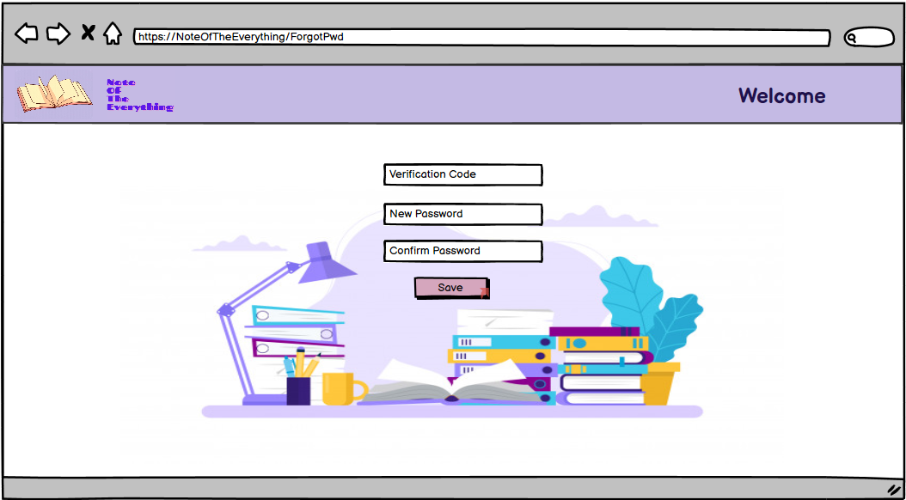

**- “Save” button is clicked in the ForgotPassword page;**

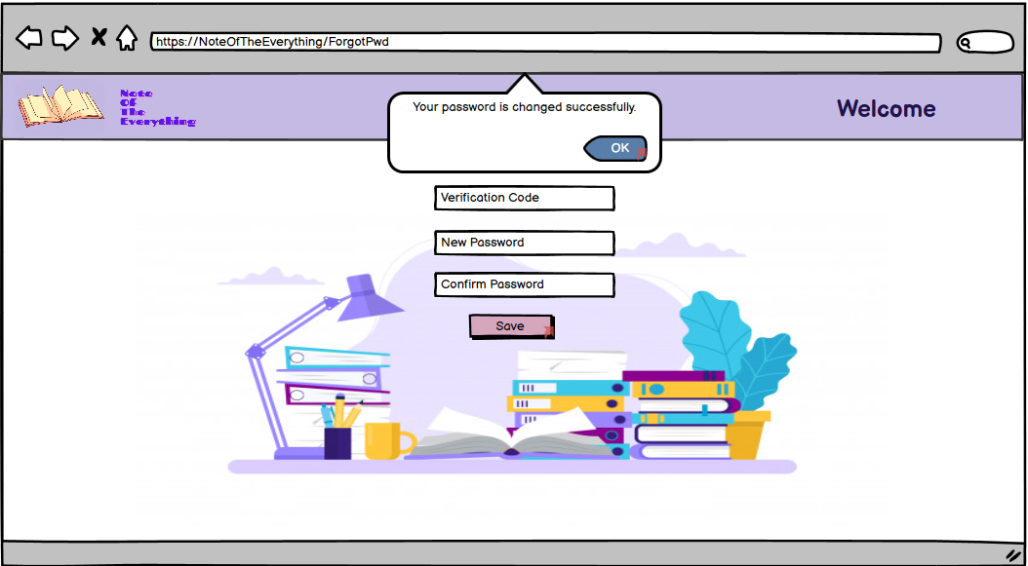

**-”Login” button is clicked in the HomePage;**

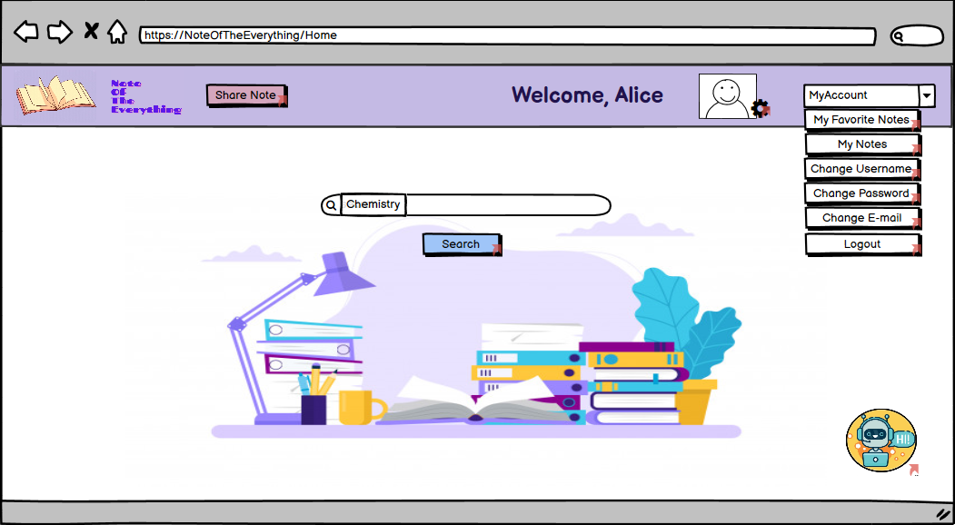

**-”Search” button is clicked in the Home;**

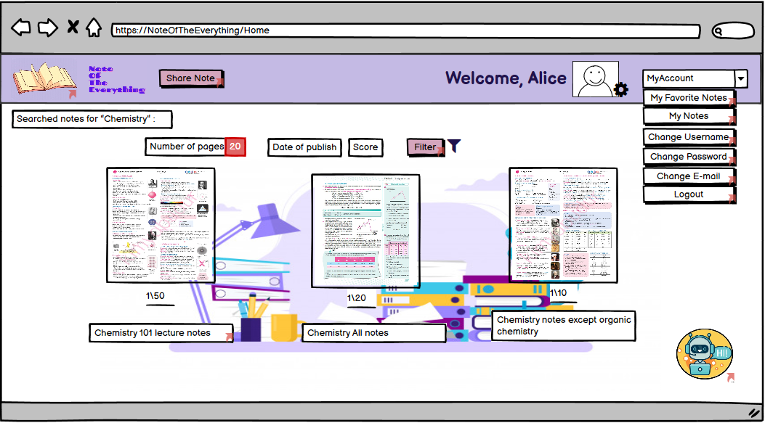

**-”Filter” button is clicked in the Home;**

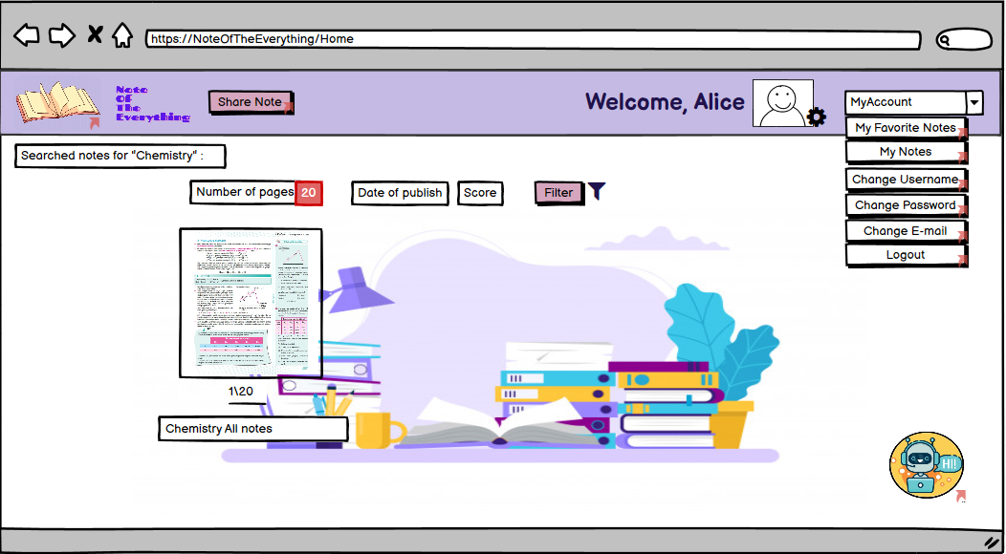

**-Selected Note;**

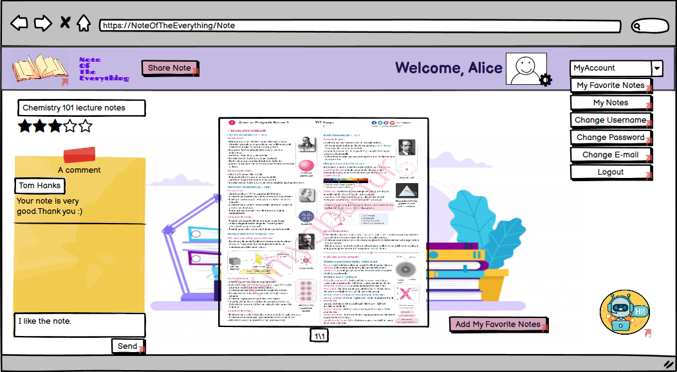

**-(Comment) ”Send” button is clicked in the Note page;**

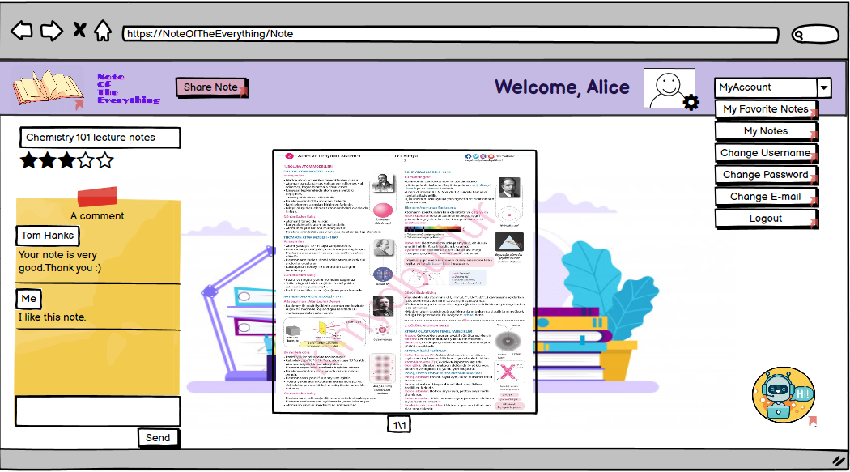

**-”Share Note” button is clicked;**

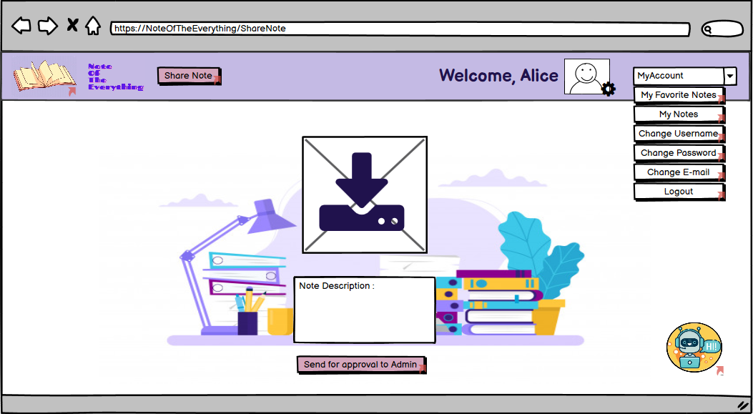

**-”Send for approval to Admin ” button is clicked in the ShareNote page;**

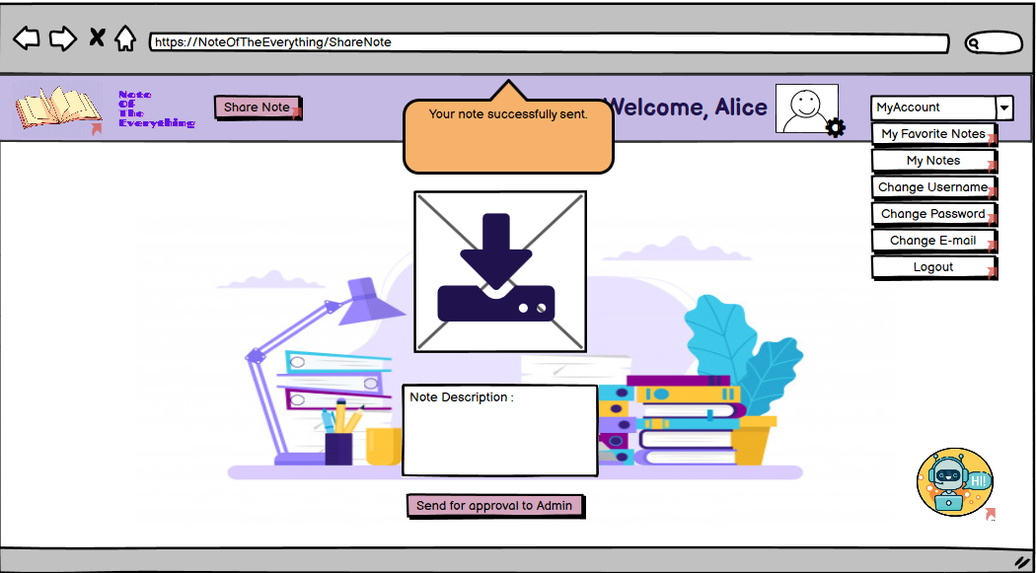

**-”My Favorites Notes” button is clicked ;**

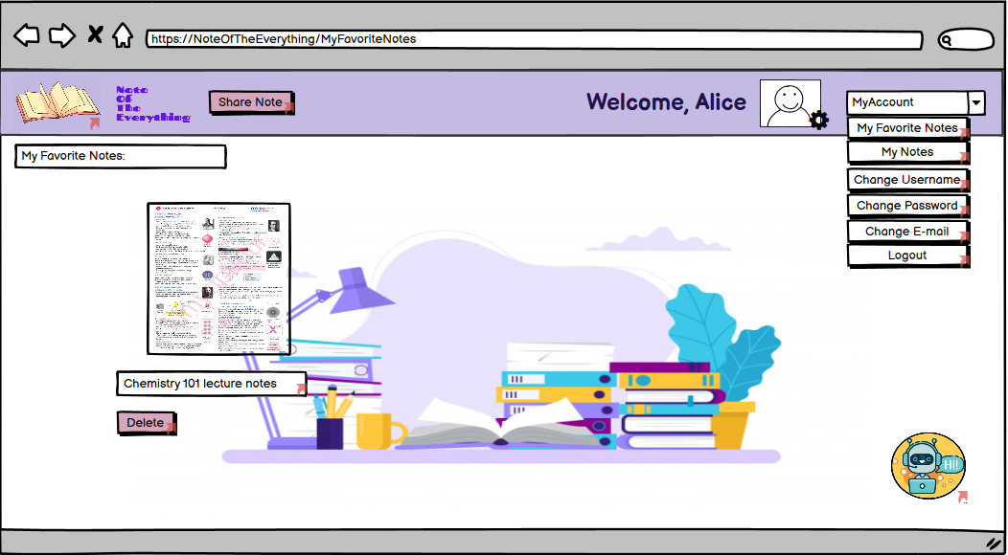

**-”Delete” button is clicked in MyFavoriteNotes page;**

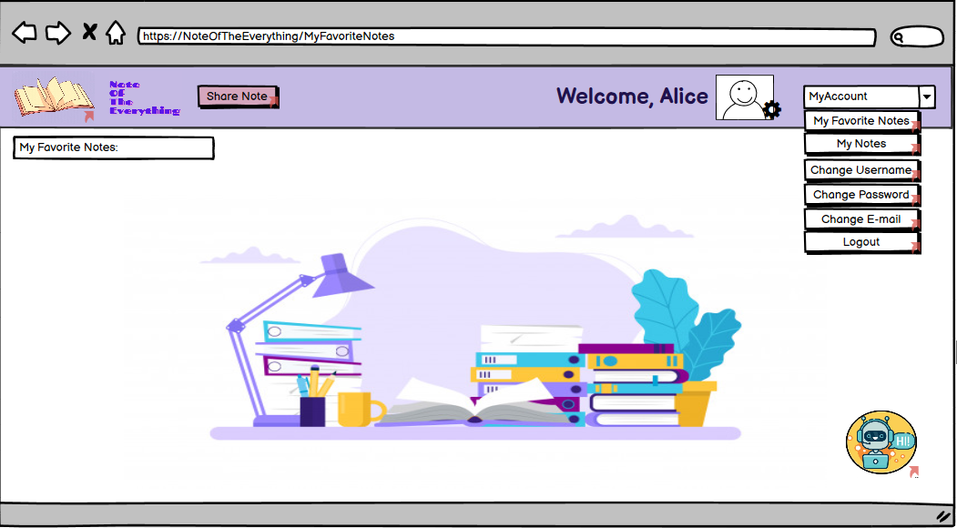

**-”My Notes” button is clicked;**

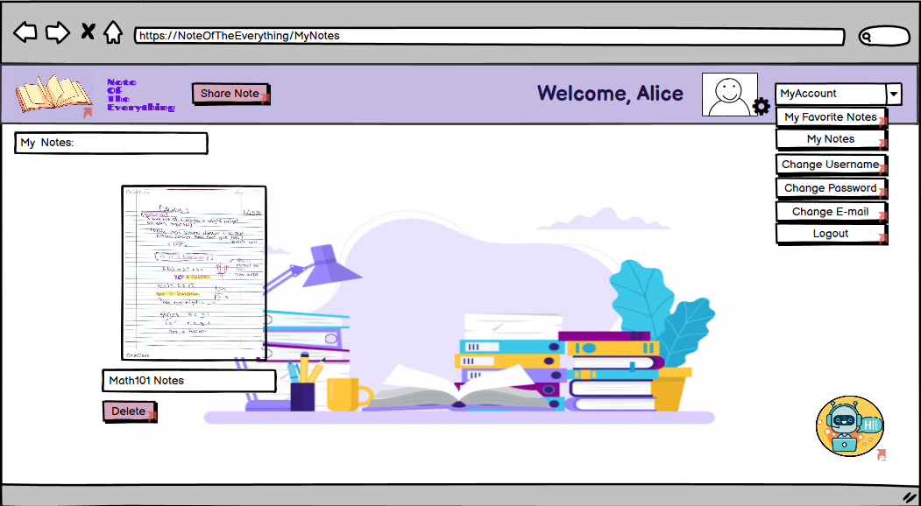

**-”Delete” button is clicked in MyFavoriteNotes page;**

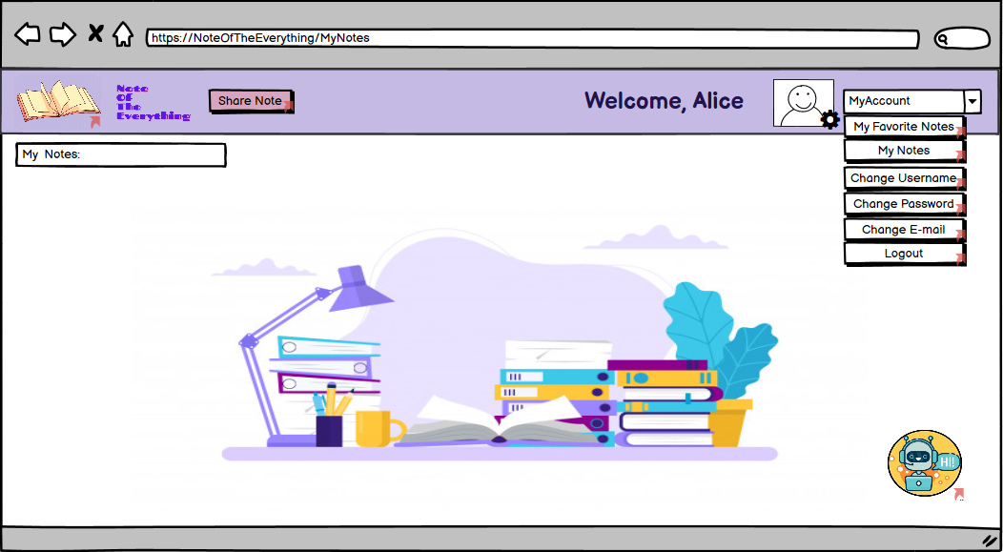

**-”Change Username” button is clicked;**

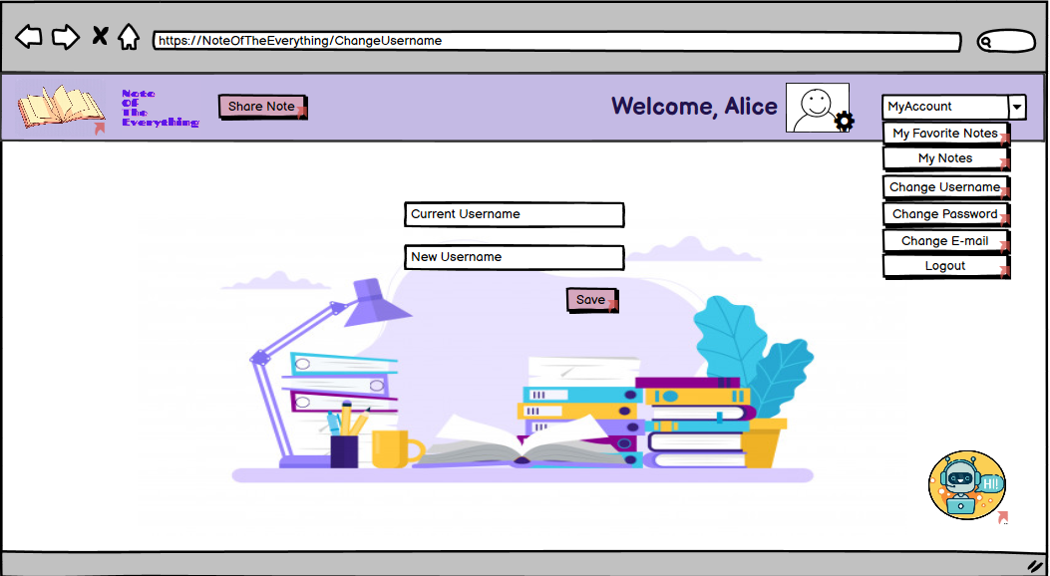

**-”Save” button is clicked in the ChangeUsername page;**

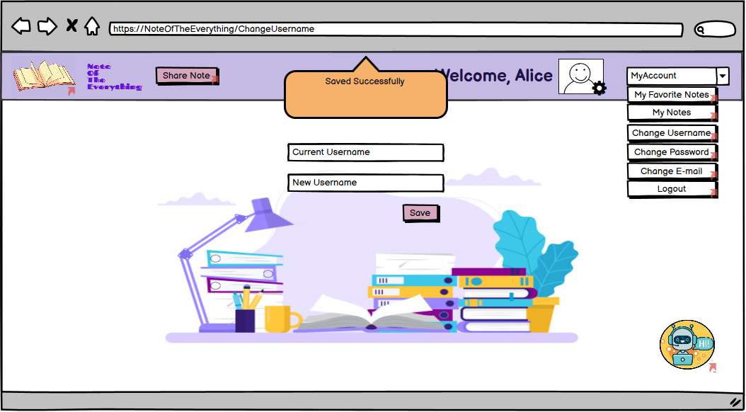

**-”Change Password” button is clicked;**

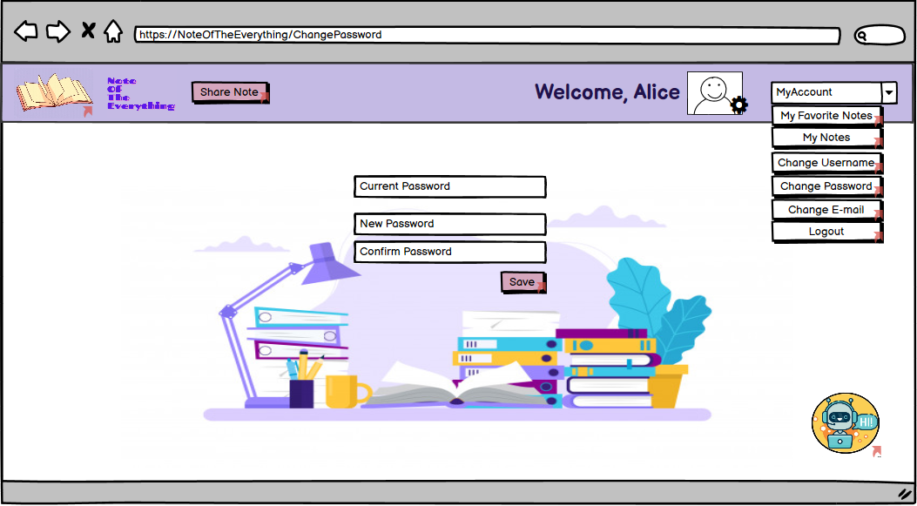

**-”Save” button is clicked in the ChangePassword page;**

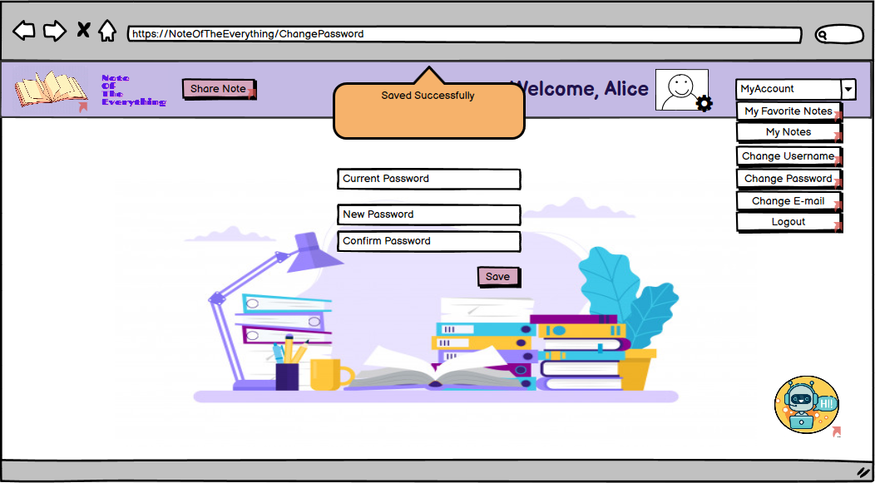

**-”Change Email” button is clicked;**

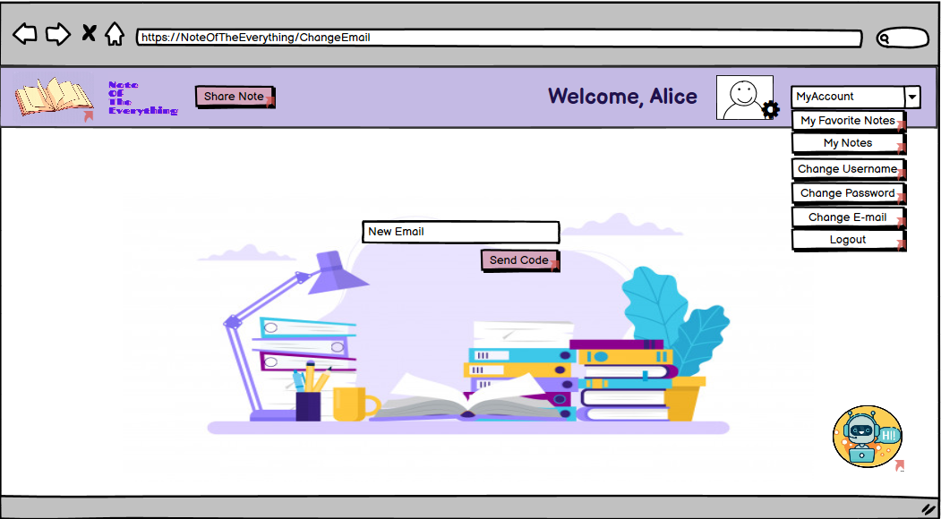

**-”Send Code” button is clicked in the ChangeEmail page;**

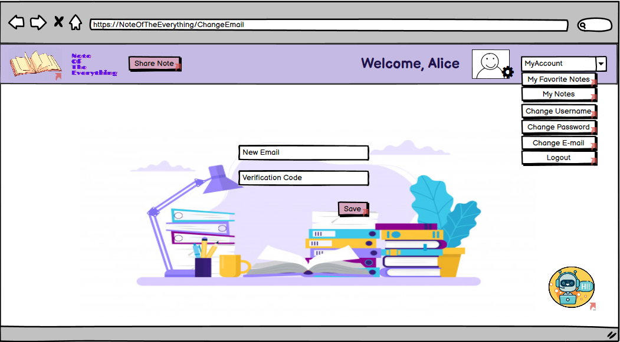

**-”Save” button is clicked in the ChangeEmail page;**

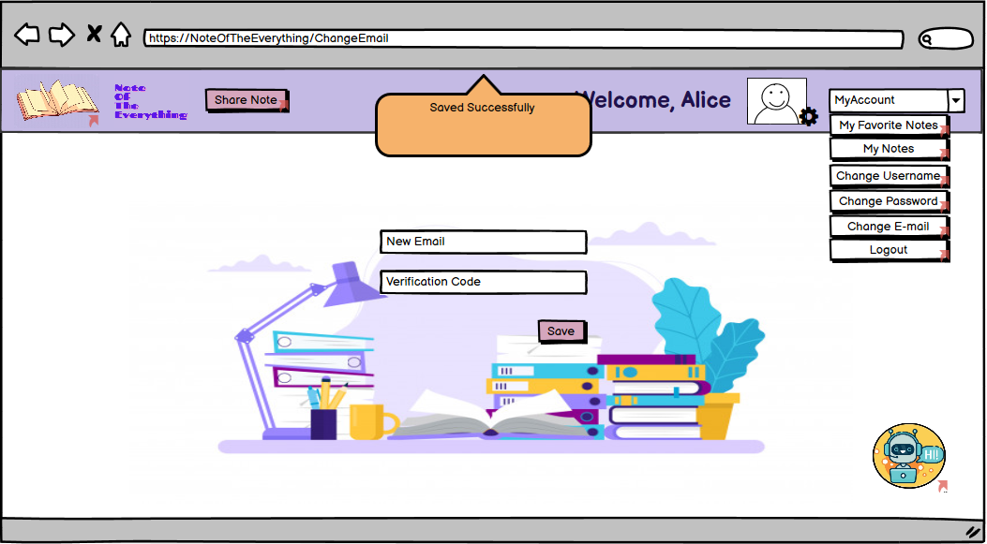

**-The ChatBot(“NoteBot”) icon in the bottom right corner of the page is clicked;**

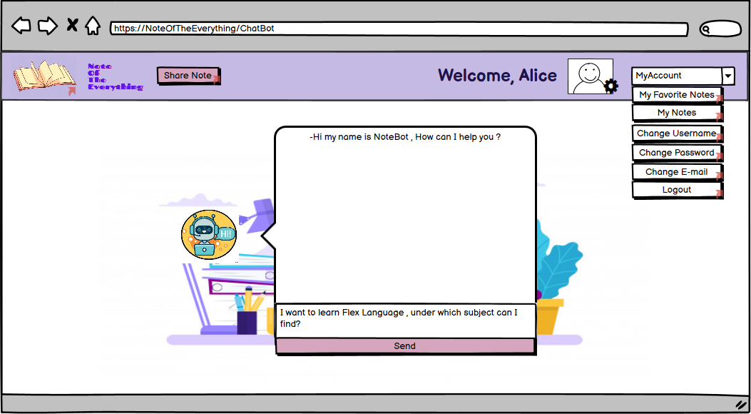

**-Admin HomePage ;**

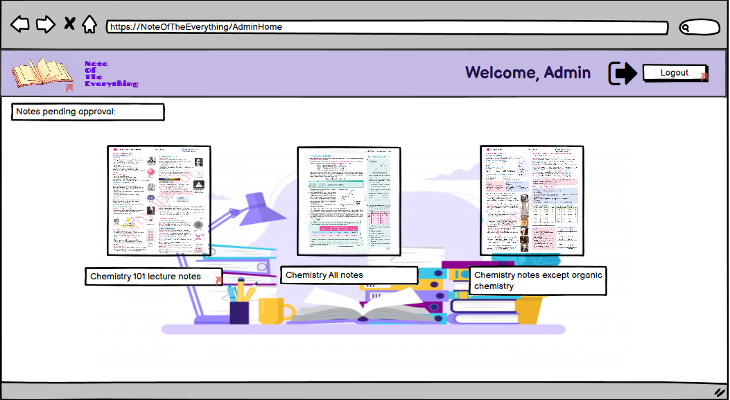

**-Notes pending page for admin approval;**

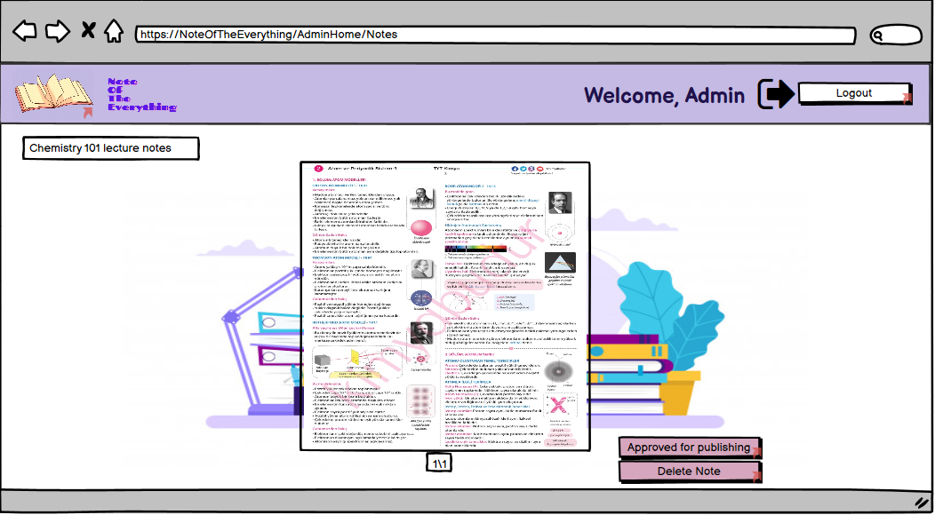

**-”Approved for publishing” button is clicked;**

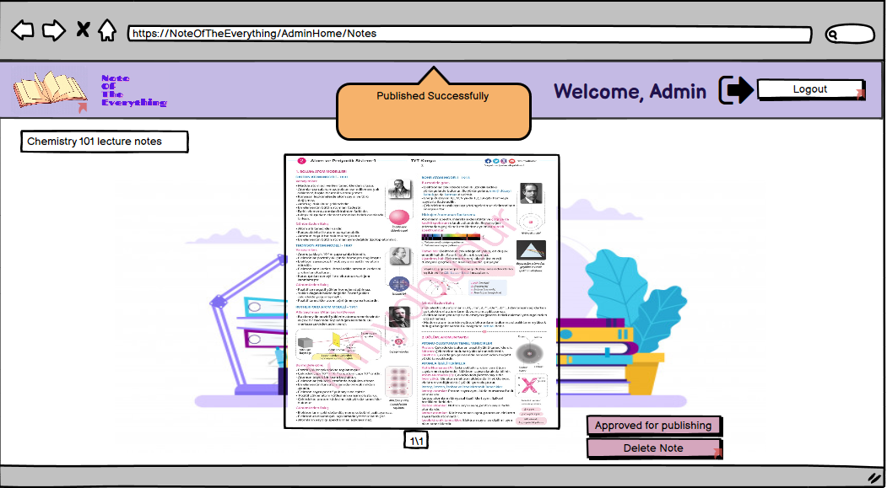

**-”Delete Note” button is clicked;**

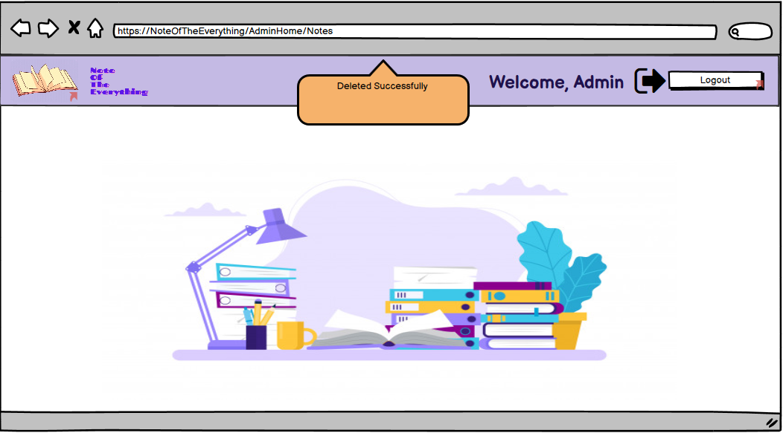

1. **Glossary**

Registered User: Registered person on the website.

Guest: The person who can access the registration page.

Admin: People who control the system.

System: NoteOfTheEverything

1. **References**
2. Bruegge B. & Dutoit A.H.. (2010). *Object-Oriented Software Engineering Using UML, Patterns, and Java*, Prentice Hall, 3rd ed.
3. <https://notedu.com/>
4. <https://notunupaylas.com/>
5. <http://notkutusu.com/>